Bahria University,

Karachi Campus



LAB EXPERIMENT NO.  
02

LIST OF TASKS

|  |  |
| --- | --- |
| TASK NO | OBJECTIVE |
| **QUESTION:1** | Which type of sorting you want to apply? Create a menu having the following options:   * 1. Bubble Sort Method   2. Selection Sort Method   3. Insertion Sort |
| **QUESTION:**2 | Implement Selection sort and print string array data in descending order. |
| **QUESTION:**3 | A Detox chemical Industry has a list of chemicals along with their concentration and Volume. Your task is to list down the name of chemicals in descending order based on their Volume. In order to fulfil the task you have to select any of the sorting method taught in today’s lab with proper reasoning of usage of that algorithm. |
| **QUESTION:**4 | You have to write a program which take input from the user and place the value on correct location in ascending order. |
| QUESTION:5 | Write a program which take N numbers of grocery items from user along with their price. Your main task is to display the items in sorted format. Then allow user to search for any of the item from that list by using name of the item. |

Submitted On:   
 **26-09-19**

(Date: DD/MM/YY)

**QUESTION : 01**

Which type of sorting you want to apply? Create a menu having the following options:

1. Bubble Sort Method
2. Selection Sort Method
3. Insertion Sort

**CODE:**

static void Bubble_Sort(int[] arr, int n)

{

int k;

for (int i = n; i >= 0; i--)

{

for (int j = 0; j < n - 1; j++)

{

k = j + 1;

if (arr[j] > arr[k])

{

int temp;

temp = arr[j];

arr[j] = arr[k];

arr[k] = temp;

}

}

}

}

static void Selection_Sort(int[] arr, int n)

{

int temp, smallest;

for (int i = 0; i < n - 1; i++)

{

smallest = i;

for (int j = i + 1; j < n; j++)

{

if (arr[j] < arr[smallest])

{

smallest = j;

}

}

temp = arr[smallest];

arr[smallest] = arr[i];

arr[i] = temp;

}

}

static void Insertion_Sort(int[] arr)

{

for (int i = 0; i < arr.Length - 1; i++)

{

for (int j = i + 1; j > 0; j--)

{

if (arr[j - 1] > arr[j])

{

int temp = arr[j - 1];

arr[j - 1] = arr[j];

arr[j] = temp;

}

}

}

}

static void Main(string[] args)

{

int[] a = new int[4];

Console.WriteLine("Enter Elements Of The Array: ");

for (int i = 0; i < a.Length; i++)

{

Console.Write("{0} = ", i);

a[i] = int.Parse(Console.ReadLine());

}

char choice;

Console.WriteLine("Select desired Items from the given menu:");

Console.WriteLine("For Bubble Sort Enter A:");

Console.WriteLine("For Selection Sort Enter B:");

Console.WriteLine("For Insertion Sort Enter C:");

Console.WriteLine("Enter exit to leave");

Console.Write("Please Enter A-C or type exit = ");

choice = Char.Parse(Console.ReadLine());

switch (choice)

{

case 'A':

Bubble_Sort(a, a.Length);

for (int i = 0; i < a.Length; i++)

{

Console.Write(a[i] + " ");

}

break;

case 'B':

Selection_Sort(a, a.Length);

for (int i = 0; i < a.Length; i++)

{

Console.Write(a[i] + " ");

}

break;

case 'C':

Insertion_Sort(a);

for (int i = 0; i < a.Length; i++)

{

Console.Write(a[i] + " ");

}

break;

case '0':

break;

default:

Console.WriteLine("Invalid Entry");

break;

}

**OUTPUT:**

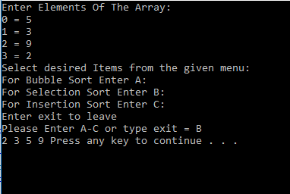  **QUESTION : 02**Implement Selection sort and print string array data in descending order.

**CODE:**

static void Selection_Sort(String[] arr, int n)

{

int smallest;

String temp;

for (int i = 0; i < n - 1; i++)

{

smallest = i;

for (int j = i + 1; j < n; j++)

{

if (arr[j].ToLower().First() > arr[smallest].ToLower().First())

{

smallest = j;

}

}

temp = arr[smallest];

arr[smallest] = arr[i];

arr[i] = temp;

}

}

static void Main(string[] args)

{

String[] a = new String[10];

Console.WriteLine("****************Enter Elements Of The

Array**************");

for (int i = 0; i < a.Length; i++)

{

Console.Write("{0} = ", i);

a[i] = Console.ReadLine();

}

Console.WriteLine();

Console.WriteLine("***************Array In Descending

Order*****************");

Selection_Sort(a, a.Length);

for (int i = 0; i < a.Length; i++)

{

Console.WriteLine(a[i] + " ");

}

Console.WriteLine();

}

}

**OUTPUT:**

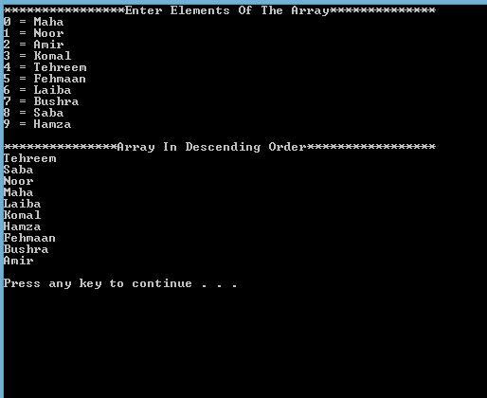

**QUESTION : 03**

A Detox chemical Industry has a list of chemicals along with their concentration and Volume. Your task is to list down the name of chemicals in descending order based on their Volume. In order to fulfil the task you have to select any of the sorting method taught in today’s lab with proper reasoning of usage of that algorithm. **CODE:**

static void Selection_Sort(String[,] arr)

{

String temp, volume, concentration;

for (int i = 0; i < (arr.Length / 3) - 1; i++)

{

for (int j = i + 1; j > 0; j--)

{

float b = float.Parse(arr[j - 1, 2]);

float f = float.Parse(arr[j, 2]);

if (b < f)

{

temp = arr[j - 1, 0];

arr[j - 1, 0] = arr[j, 0];

arr[j, 0] = temp;

concentration = arr[j - 1, 1];

arr[j - 1, 1] = arr[j, 1];

arr[j, 1] = concentration;

volume = arr[j - 1, 2];

arr[j - 1, 2] = arr[j, 2];

arr[j, 2] = volume;

}

}

}

}

static void Main(string[] args)

}

String[,] a = new String[5,3];

Console.WriteLine("**********************Chemicals****

*********************");

for (int i = 0; i < a.Length / 3; i++)

{

Console.Write("{0} Chemical = ", i);

a[i, 0] = Console.ReadLine();

Console.Write(" Concentration = ");

a[i, 1] = Console.ReadLine();

Console.Write(" Volume = ");

a[i, 2] = Console.ReadLine();

}

Console.WriteLine();

Console.WriteLine("*******************Array After

Sorting*******************");

for (int i = 0; i < a.Length / 3; i++)

{

Console.Write(" " + a[i, 0] + " " + "\t" + a[i, 1] + " " + "\t" + a[i, 2]);

Console.WriteLine();

}

Console.WriteLine();

Selection_Sort(a);

Console.WriteLine("***************Array In Descending

Order*****************");

for (int i = 0; i < a.Length / 3; i++)

{

Console.Write(" " + a[i, 0] + " " + "\t" + a[i, 1] + " " + "\t" + a[i, 2]);

Console.WriteLine();

}

Console.WriteLine();

}

}

**OUTPUT:**

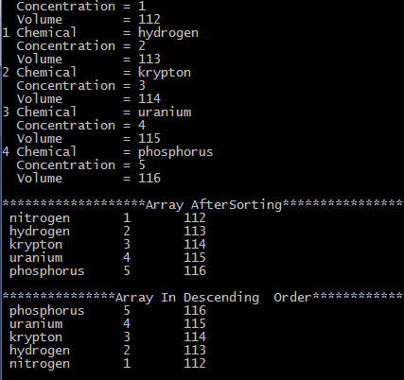

**QUESTION : 04**You have to write a program which take input from the user and place the value on correct location in ascending order. **CODE:**  
 static void Main(string[] args)

{

int[] arr1 = new int[10];

int n, i, j, tmp;

Console.Write("\n\nSort elements of array in descending order :\n");

Console.Write("----------------------------------------------\n");

Console.Write("Input the size of array : ");

n = Convert.ToInt32(Console.ReadLine());

Console.Write("Input {0} elements in the array :\n", n);

for (i = 0; i < n; i++)

{

Console.Write("{0} : ", i);

arr1[i] = Convert.ToInt32(Console.ReadLine());

}

for (i = 0; i < n; i++)

{

for (j = i + 1; j < n; j++)

{

if (arr1[j] > arr1[i])

{

tmp = arr1[i];

arr1[i] = arr1[j];

arr1[j] = tmp;

}

}

}

Console.Write("\nElements of array in sorted descending order:\n");

for (i = 0; i < n; i++)

{

Console.Write("{0} ", arr1[i]);

}

Console.Write("\n\n");

}

**OUTPUT:** 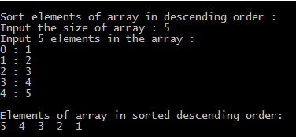

**QUESTION : 05**

Write a program which take N numbers of grocery items from user along with their price. Your main task is to display the items in sorted format. Then allow user to search for any of the item from that list by using name of the item.

**CODE:**

public static void LinearSearch(String[,] Arr, String item)

{

for (int i = 0; i < Arr.Length / 2; i++)

{

if (Arr[i, 0].ToLower() == item.ToLower())

{

Console.WriteLine("Item Found at {0}", i);

Console.WriteLine(Arr[i, 0] + " " + Arr[i, 1]);

}

}

}

static void Selection_Sort(String[,] arr, int n)

{

int smallest;

String temp, price;

for (int i = 0; i < n / 2; i++)

{

smallest = i;

for (int j = i + 1; j < n; j++)

{

if (arr[i, 0].ToLower().First() < arr[smallest, 0].ToLower().First())

{

smallest = j;

}

}

temp = arr[smallest, 0];

arr[smallest, 0] = arr[i, 0];

arr[i, 0] = temp;

price = arr[smallest, 1];

arr[smallest, 1] = arr[i, 1];

arr[i, 1] = price;

}

}

static void Main(string[] args)

{

String[,] a = new String[10, 2];

Console.WriteLine("********************Grocery

Items**********************");

for (int i = 0; i < a.Length / 2; i++)

{

Console.Write("{0} Name = ", i);

a[i, 0] = Console.ReadLine();

Console.Write("{0} Price= ", i);

a[i, 1] = Console.ReadLine();

}

Console.WriteLine();

Console.WriteLine("*****************Array After

Sorting*********************");

Selection_Sort(a, a.Length);

for (int i = 0; i < a.Length / 2; i++)

{

Console.Write(a[i, 0] + " " + a[i, 1]);

Console.WriteLine();

}

Console.WriteLine();

Console.Write("Input Search = ");

string input = Console.ReadLine();

LinearSearch(a, input);

}

}

**OUTPUT:**

